**The history of the Hollywood sign,**

Every year at the Oscars, the cameras pan to the famed Hollywood sign and its bold white letters.

Ask someone today what the sign symbolizes, and the same words will likely crop up: *Movies. Stardom. Glamour.*

But as I point in [my book on the Hollywood sign](https://books.google.com/books?id=eEnLlfsGfGkC&printsec=frontcover&dq=hollywood+sign+leo+braudy&hl=en&sa=X&ved=0ahUKEwjLkpmk7b_ZAhUFR6wKHR0pCq8Q6AEIJzAA#v=onepage&q&f=false), the sign didn’t always represent fame and fortune. As the city changed, so did the meaning of the sign, which, at one point, was even considered a public nuisance.

**Come to … Hollywood land?**

California has long possessed the lure of material and personal fulfillment.

What started as a destination for those hoping to strike gold became, in the late 19th century, a mecca for anyone with real or imagined ailments. The state’s temperate climate and natural springs, [guidebooks claimed](https://books.google.com/books?id=zm5oBAAAQBAJ&pg=PA43&lpg=PA43&dq=california+health+destination+19th+century&source=bl&ots=gFkRyLbfW1&sig=5hWBgDNks80_z2mnZvn7ITx1a-o&hl=en&sa=X&ved=0ahUKEwjW0tesscnZAhUBMqwKHcnRANAQ6AEITzAF#v=onepage&q=california%20health%20destination%2019th%20century&f=false), possessed “restorative powers for weakened dispositions.”

The state’s gold has since been drained, and the quest for perfect health has spread to rest of the country. But the erection of the famed Hollywood sign in 1923 marked the start of another phase, one still with us today.

During that decade, a real estate development group, one of whose principal backers was Los Angeles Times publisher Harry Chandler, built a large sign – essentially a billboard – on an unnamed mountain between the Los Angeles basin and the San Fernando Valley.

“Hollywoodland,” the sign read. Its 40,000 blinking light bulbs advertised a new housing development built to accommodate the city’s surging population, which [more than doubled](http://www.laalmanac.com/population/po02.php) during the 1920s to become the fifth largest in the country, as the city drew people from all over the country for its weather, open spaces and jobs.

[[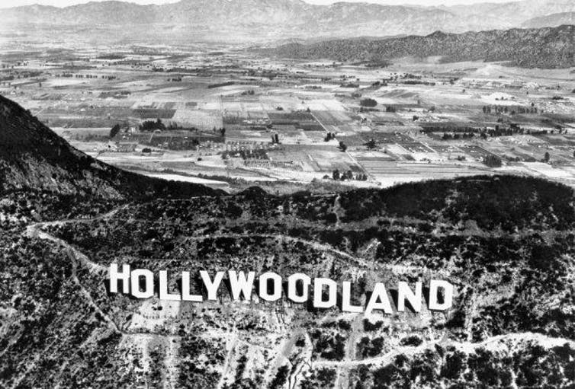](https://images.theconversation.com/files/193665/original/file-20171107-6733-1pjbpw5.jpg?ixlib=rb-1.1.0&q=45&auto=format&w=1000&fit=clip)](https://images.theconversation.com/files/193665/original/file-20171107-6733-1pjbpw5.jpg?ixlib=rb-1.1.0&q=45&auto=format&w=1000&fit=clip)

A sweeping view of the Hollywoodland sign. [Breve Storia del Cinema](https://c2.staticflickr.com/8/7561/15647647441_0d8d1d1bf0_z.jpg)

The city of Hollywood [had been absorbed](https://www.discoverlosangeles.com/blog/historical-timeline-los-angeles) into Los Angeles only a decade earlier. At the time, it was a wealthy area that had grudgingly accepted the movie business. Many mansions dotted the hillsides below the sign, and utopian communities like [Krotona](https://la.curbed.com/2014/5/22/10099768/the-creation-of-beachwood-canyons-theosophist-dreamland-1), the U.S. headquarters of a mystical organization called the Theosophical Society, had sprung up in the foothills and on the flats.

Accordingly, early advertising for Hollywood land emphasized the development’s exclusivity. It would offer an escape from the smog, dirt and unwelcome neighbors of downtown Los Angeles.

**Saving the sign**

Because the sign holds such a prominent place in the nation’s cultural imagination today, it may be surprising to learn that it wasn’t until fairly recently that it achieved its iconic status.

In the 1930s and 1940s, the sign makes an appearance in only a few of the movies that were about Hollywood or the movie industry. Other Hollywood institutions, like the [Brown Derby restaurant](http://brownderbyhollywood.com/about.html), tended to represent the film world.

In the 1940s, Los Angeles – as both city and symbol – started to change. A dense smog settled over the metropolis, which would be featured as the grim, shadowy setting of noir films like “[The Big Sleep](http://www.imdb.com/title/tt0038355/?ref_=adv_li_tt)” and “[Double Indemnity](http://www.imdb.com/title/tt0036775/?ref_=adv_li_tt).”

The sign – a little dingier, a little more unslightly – reflected the changing city. Since it was originally intended as an advertisement, few had considered its permanence or long-term significance.

The hillside where it had been built was dangerously steep; workers had cut the letters from thin sheet metal, which they tacked onto telephone poles. Heavy winds could easily rip the letters away, and by the late 1940s, there had been so much deterioration that the city of Los Angeles proposed to tear it down, calling it a dangerous public nuisance.

[[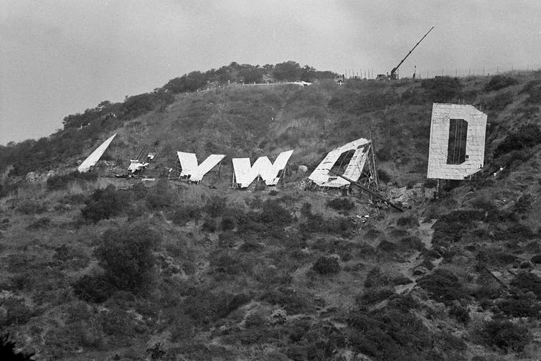](https://images.theconversation.com/files/193658/original/file-20171107-6733-1vd7y81.jpg?ixlib=rb-1.1.0&q=45&auto=format&w=1000&fit=clip)](https://images.theconversation.com/files/193658/original/file-20171107-6733-1vd7y81.jpg?ixlib=rb-1.1.0&q=45&auto=format&w=1000&fit=clip)

In this 1978 photograph, workers prepare to lower the last letter of the old Hollywood sign that had stood at the site since the 1920s. [Wally Fong/AP Photo](http://www.apimages.com/metadata/Index/Watchf-AP-A-ENT-CA-USA-APHS462574-Hollywood-Sign-1978/2e26f25fa66743fd8a31003e114c9703/78/0)

That dismissive view of the sign began to change in 1949, when the Hollywood Chamber of Commerce [told the city that it would take over its ownership and maintenance](https://www.cbsnews.com/news/hollywood-sign-sold-for-450k/). With that exchange, the “land” suffix was dropped. We could say that this is the point that the Hollywood sign we know today was actually born.

However, improvements and maintenance occurred in fits and starts. By the early 1970s, committees were being formed to “save” the sign in order to restore it beyond shoddy paint jobs and patchwork repairs.

Finally, in 1978 a committee headed by Hugh Hefner and Alice Cooper collected the funds – about US$27,000 per letter – to not simply repair, [but rebuild the sign](https://www.vanityfair.com/hollywood/2017/09/hugh-hefner-hollywood-sign).

Today the big white letters are a permanent fixture in the Los Angeles landscape, and it’s even withstood the attempts of adventurous vandals to emulate [the art student](http://www.cnn.com/2017/01/01/us/hollywood-hollyweed-sign/index.html) who, in 1976, tweaked the sign to read “[Hollyweed](http://www.trbimg.com/img-58694e84/turbine/la-lnelson-1483296437-snap-photo).”

In their own way, these vandals are trying to carve out their own slice of the Hollywood dream – a quest not for gold or for health, but for recognition and fame, whether by talent, ambition or selfie.

# Interesting Facts about the Hollywood Sign

The iconic Hollywood sign has loomed over the epicenter of American movie making since 1923, and its 92 year history includes plenty of interesting tidbits.  
1. The sign wasn’t created to advertise movies and starlets; it was created to advertise real estate. Developers S. H. Woodruff and Tracy E. Shoults began developing a new neighbourhood called “Hollywoodland.” The sign was meant to act as a huge billboard to draw new home buyers to the hillside.  
2. The sign read HOLLYWOODLAND from 1923 to 1949.

3. Considering that the original Hollywoodland sign was only intended to be an advertisement for a real estate development, it was quite expensive. The construction cost of the sign was around $21,000, which is roughly the equivalent of $250,000 in 2015 dollars. Imagine building a new neighbourhood and paying a quarter of a million bucks to advertise it with one sign!  
4. Each letter originally stood 15 meters and 9.1 meters wide high, but renovations in 1978 resized the letters to 14 m tall and anywhere from 9.4 to 12 meters wide.  
5. 4000 light bulbs graced the Hollywoodland Sign. The bulbs were timed to blink so that the words “HOLLY,” “WOOD,” and “LAND” each lit up consecutively, followed by the entire word. This was not considered tacky, but rather quite progressive and modern. Each bulb generated only 8 watts of electricity, so 4,000 were needed in order to create the impressive display that Woodruff and Shoults needed to sell building lots.  
6. The stock market crash of 1929 and the subsequent Depression during the 1930’s halted real estate development. Since lots were no longer being sold, illuminating the Hollywoodland sign was no longer a priority. Times were tough, so caretaker Albert Kothe stripped the copper wiring from the sign and sold it for scrap.  
7. In 1932, Broadway actress Peg Entwistle committed suicide by jumping off the letter “H.”  
8. In the 1940s, the sign’s official caretaker, Albert Kothe, destroyed the “H” after crashing into it while driving drunk.

9. The paint job in 1973 didn’t last for long. Five years later, the sign looked worse than ever. The Chamber of Commerce determined that it needed a very expensive overhaul. Hugh Hefner held a fundraiser at the Playboy Mansion. Each of the nine letters was auctioned for $28,000 to raise the needed renovation money. The benefactors for each letter were as follows:  
H- Terrence Donnelly (a newspaper publisher)  
O- Alice Cooper (rock star)  
L- Les Kelley (businessman and creator of the Kelley Blue Book)  
L- Gene Autrey (singer and actor)  
Y- Hugh Hefner (founder of Playboy magazine)  
W- Andy Williams (singer)  
O-Giovanni Mazza (Italian movie producer)  
O- Warner Bros. Studios  
D-Thomas Pooley

10. In January 1976, following the passage of a state law decriminalizing marijuana, vandals altered the sign to read ” HOLLYWeeD.”

11. In 1984, Los Angeles hosted the Olympic Summer Games. During the games, the Hollywood sign was illuminated for the first time since the 1930s.  
12. In order to keep people away from the sign and keep the sign from being vandalized, a specially-designed security system was developed. The Department of Homeland Security even got involved… that’s how serious L.A. is about protecting its iconic sign. The security involves razor wire, infrared technology, 24 hour monitoring, motion sensors, alarms and helicopter patrols.  
13. The Hollywood Sign Trust was created in 1992 for the purpose of maintaining and promoting the Hollywood sign. It continues to care for the sign today. The most recent renovation included a shiny, new paint job and webcams that allow Internet visitors to see the sign 24/7.

|  |  |
| --- | --- |
| **Hollywood Sign** | |
| The Hollywood Sign in 2015 | |
| [Location within Los Angeles Metropolitan Area](https://en.wikipedia.org/wiki/File:USA_Los_Angeles_Metropolitan_Area_location_map.svg)  Location within Los Angeles Metropolitan Area  Location within [Los Angeles Metropolitan Area](https://en.wikipedia.org/wiki/Los_Angeles_Metropolitan_Area) | |
| **Former names** | Hollywoodland Sign (1923–1949) |
| **General information** | |
| **Location** | [Griffith Park](https://en.wikipedia.org/wiki/Griffith_Park), [Mount Lee](https://en.wikipedia.org/wiki/Mount_Lee), [Hollywood Hills](https://en.wikipedia.org/wiki/Hollywood_Hills), Los Angeles, California |
| **Country** | [United States](https://en.wikipedia.org/wiki/United_States) |
| [**Coordinates**](https://en.wikipedia.org/wiki/Geographic_coordinate_system) | [34°8′2.62″N 118°19′17.73″W](https://geohack.toolforge.org/geohack.php?pagename=Hollywood_Sign&params=34_8_2.62_N_118_19_17.73_W_region:-CA_type:landmark)[Coordinates](https://en.wikipedia.org/wiki/Geographic_coordinate_system): [34°8′2.62″N 118°19′17.73″W](https://geohack.toolforge.org/geohack.php?pagename=Hollywood_Sign&params=34_8_2.62_N_118_19_17.73_W_region:-CA_type:landmark) |
| **Completed** | 1923 |
| **Renovated** | Repaired 1949 rebuilt 1978 repainted 2005 |
| **Cost** | $21,000 |
| **Client** | Woodruff and Shoults (Hollywoodland) |
| **Technical details** | |
| **Structural system** | Wood and sheet metal (1923–1978) Steel (1978–present) |
| **Size** | 45 ft (13.7 m) tall,[[1]](https://en.wikipedia.org/wiki/Hollywood_Sign#cite_note-SignFacts-1) 350 ft (106.7 m) long[[1]](https://en.wikipedia.org/wiki/Hollywood_Sign#cite_note-SignFacts-1) |
| **Design and construction** | |
| **Architect** | Thomas Fisk Goff |
|  | |
| [**Los Angeles Historic-Cultural Monument**](https://en.wikipedia.org/wiki/Los_Angeles_Historic-Cultural_Monument) | |
| **Designated** | February 7, 1973 |
| **Reference no.** | 111 |